Aidan Morganfield, Chris Olsten,

Osman Mansurov, & Omar Mansurov

Professor Fierro

CSCI403 Database Management

04/28/2025

Database Management Final Project – Title?

Introduction and overview here.

Part 1:

We are doing a combination of large dataset and mash up. Description of how our datasets meet the requirements.

Citations for both data sets here

Part 2:

We are doing Data science and analysis (we may make a software development website to interface). Overview of project, explanation of results, explanation of how this portion meets the requirements.

The first initial tests in this section are hypothesis tests. In this case, we’ll use hypothesis tests to determine if differences in categorical group means are significant enough to not simply be a coincidence.

**Do we have evidence to show that electric cars have increased in average range in 2020 compared to in 2019?**

After filtering the initial dataframe, we found the sample means and standard deviations of each group.

We can now form the null and alternative hypotheses.

After running a significance test for a difference in means, we find a very significant p-value less than 0.0001 and an estimate of . Therefore, we have enough evidence to reject the null hypothesis. In other words, we have enough evidence to show that the average range of electric cars has increased by a significantly large amount from 2019 to 2020.

**Do hybrid electric vehicles have a lower mean electric range than electric vehicles?**

No hypothesis testing has been done yet, still trying to figure out if this question is worth answer given the following table.

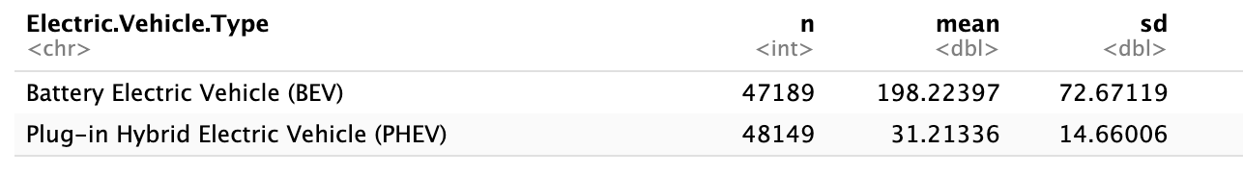

**Does Tesla sell electric vehicles with a higher average range higher than all other electric vehicle makes? Is this result statistically significant?**

Part 3:

Data loading and cleaning: Explanation

Database schema design: Explanation

Interesting or Complex Queries: Explanation

Data Visualization: Explanation

(We can change these if we want to)